API Description:
The Leave Management API allows basic employee leave tracking. Employees can request leaves, and admins can approve or reject those requests.
Features:
- Employee management
- Leave request creation and tracking
- JWT-based role authentication (Admin, Employee)
- Role-based access control
- Swagger integration for testing and documentation

Database Table:
1.Empoyee
Column Name | Data Type | Description
EmployeeId | int (PK) | Unique ID for employee
Name | varchar(100) | Full name of the employee
Email | varchar(100) | Email address
Department | varchar(50) | Department name
2 .LeaveRequest.
Column Name | Data Type | Description
LeaveId | int (PK) | Unique ID for leave request
EmployeeId | int (FK) | Refers to Employee.EmployeeId
FromDate | date | Leave start date
ToDate | date | Leave end date
Reason | varchar(200) | Reason for leave
Status | varchar(20) | Leave status (Pending/Approved/Rejected)
ERD: 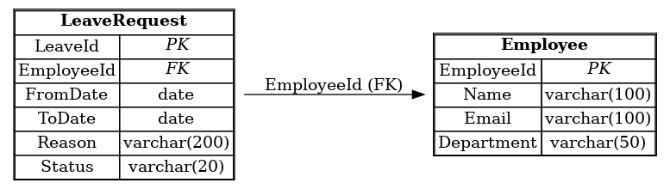
End Points List:
Authentication:
Method | Endpoint | Description
POST | /Auth/Login | Generate JWT token based on user role (Admin or Employee)
{
Role:”Admin/Employee”
}
Employee:-
Method | Endpoint | Description
GET | /employees | Get all employees
GET | /employees/{id} | Get employee by ID
POST | /employees | Add a new employee
PUT | /employees/{id} | Update an employee
DELETE | /employees/{id} | Delete an employee

LeaveRequest:-
Method | Endpoint | Description | Access
POST | /LeaveRequest | Create a new leave request | Employee
GET | /LeaveRequest | Get all leave requests | Admin
GET | /LeaveRequest/{id} | Get a specific leave request | Admin/Employee
PUT | /LeaveRequest/{id}?status=’’ | Approve or Reject a leave request | Admin
DELETE | /LeaveRequest/{id} | Delete a leave request | Employee

Leave Status Notes
Status can be one of
  - "Pending"
  - "Approved"
  - "Rejected"

